OMBRO README FILE
Date of this Document: 17 February 2011

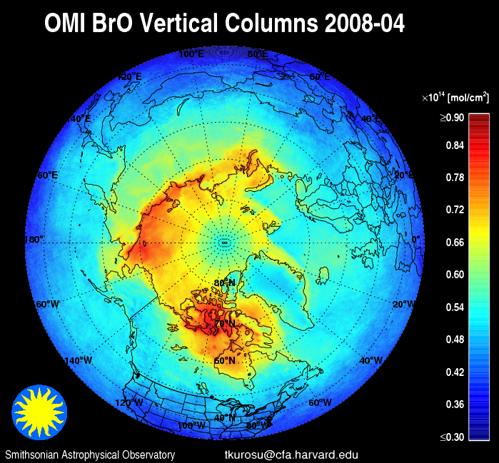
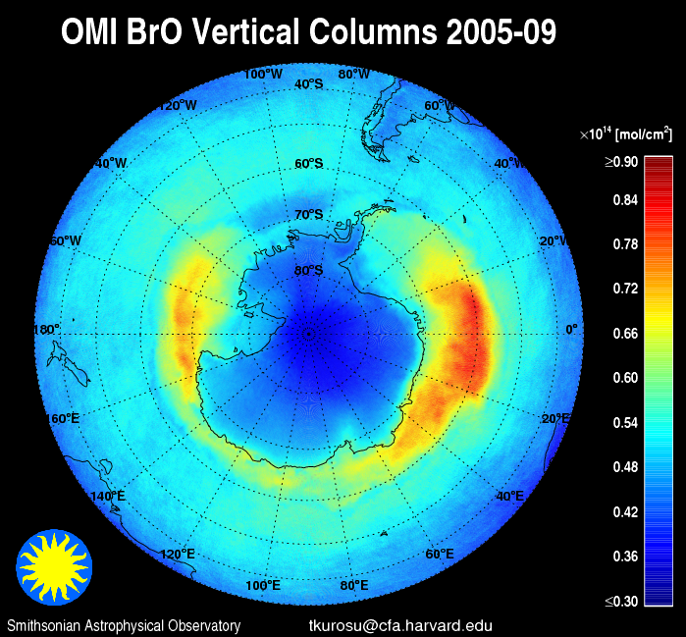

Overview
This document provides a brief description of the OMBRO data product. OMBRO contains total column BrO and ancillary information retrieved from OMI global and spatial zoom mode measurements using a retrieval algorithm that is based on non-linear least-squares fitting originally developed for GOME, and adapted for the OMI instrument. In global mode, i.e., global coverage in one day, each file contains a single orbit of data covering a swath of approximately 2,600 km wide from pole to pole (sunlit portions only).

Fitting uncertainties for the BrO slant columns (single measurement) typically range between 10-50%, with as low as 5% over BrO hotspots. This is roughly 2-4 times what was achieved from GOME. Uncertainties in the stratospheric air mass factor (AMF), used to convert slant to vertical columns, are estimated to be 10% or less. Hence the total uncertainties of the BrO vertical columns typically range within 15-51%.

The images above show monthly average BrO for April 2008 in the Arctic and for September 2009 in the Antarctic (no cloud screening).

Release History and Release-Specific Information

OMBRO Algorithm Version | 3.0
Collection/Product Version¹ | 003
This Public Release | 11 February 2011
First Public Release | 1 February 2007
Validation Release | 25 December 2005
Known Issue List | Across-track striping in the data product

Summary of Changes in This Version
V3.0 of OMBRO marks an significant improvement over V2.0, particularly in the reduction of noise in the data product, which is also associated with lower fitting uncertainties. The following changes were made to the retrieval approach in OMBRO v3.0:

◆ | The fitting window was changed to 319.0-347.5 nm.
◆ | Air Mass Factors (AMFs) are wavelength dependent and include albedo effects.
◆ | Vertical Column Densities (VCDs) are retrieved directly, with the AMFs applied to the BrO absorption cross-sections prior to fitting.
◆ | Slant Column Densities (SCDs) are retrieved with unmodified BrO absorption cross-sections and are provided in the data product under SlantColumnAmount.
◆ | Effective AMFs are calculated as AMF=SCD/VCD, and are provided as before under the data field AirMassFactor.
◆ | OMCLDO2 Cloud Fraction and Cloud-Top Pressure are provided in the data product (with some modifications) under AMFCloudFraction and AMFCloudTopPressure.
◆ | Cross-Track Quality Flags (XtrackQualityFlags) have been carried over from the L1b product to provide information on pixels affected by the Row Anomaly.
◆ | O₂-O₂ absorption has been removed from the list of interfering absorbers during the fit.
◆ | SO₂ absorption has been added to the list of interfering absorbers during the fit.

Algorithm Description
The algorithm is based on the direct fitting of radiances and irradiances. In particular, and differing from what is commonly referred to as Differential Optical Absorption Spectroscopy (DOAS) fitting, radiances are not divided by irradiances, no logarithms are taken of the spectra, and no high-pass filtering is applied.

The four main stages of the algorithm are (1) Solar wavelength calibration, in which the optimum wavelength registration of the composite solar irradiance, derived from a principal component analysis of three years of individual OMI irradiance measurements, is determined; (2) Radiance wavelength calibration, which finds the optimum wavelength registration for a representative swath of radiance measurements (usually in the middle of the orbit) and determines a common wavelength grid for auxiliary data bases (molecular reference cross sections, etc.); (3) On-line computation of a residual “common mode” spectrum; and (4) Non-linear, least-squares fitting of all swath lines in the OMI granule. In each stage, the calibration/fitting is performed individually for the 60 cross-track pixels of an OMI swath line. For improved numerical stability, radiances and irradiances are divided by their respective averages over the fitting window; in other words, they are “normalized” to values ~1.

BrO fitting is performed in the spectral window 319.0–347.5nm, within the UV-2 channel of the OMI instrument. The model that is fitted to the measurements consists of the solar reference, attenuated by contributions from BrO (the target gas), inelastic (rotational Raman, or Ring) scattering, and interferences from from other atmospheric gases, including NO₂, H₂CO, and SO₂ (but not O₂!) it also contains additive and multiplicative closure polynomials and parameters for spectral shift and, potentially, squeeze, as well as a sampling correction [Chance et al., 2005] and a common mode spectrum, both of which are computed on-line. The common mode spectra (one per cross-track position) are the average of several hundred fitting residuals and include any instrument effects that are unrelated to molecular scattering and absorption cross sections. The least-squares fit is mostly unconstrained, with the exception of selected parameters, including the spectral shift, which are constrained in order to prevent problems arising from out-of-bounds values.

A major difference of OMBRO v3.0 compared to previous version is that the current BrO retrieval uses albedo- and wavelength-dependent air mass factors (AMFs), which as in previous versios have been pre-computed using climalogical BrO profiles. AMF wavelength-dependence was introduced to take into account the strongly varying ozone absorption over the BrO fitting window, which cannot be properly accounted for with a single value over the entire window (as is customary in a standard AMF approach). The wavelength-dependent AMF is now applied pre-fit to the BrO cross-sections, and the spectral fit retrieves vertical column densities (VCDs) directly. In order to provide the AMF, as in previous versions of the product, a second run of all OMI spectra is performed with unmodified cross-sections, which yields slant column densities (SCDs). An effective AMF can then be computed as AMF=SCD/VCD. The OMBRO v3.0 product contains the VCDs, SCDs, and the effective AMFs.

The algorithm employs several methods to reduce cross-track striping of the BrO columns. These include outlier screening in the fitting residuals, the use of a composite solar spectrum (all employed during the fitting process), as well as a post-processing cross-track smoothing of the fitted columns. These smoothed columns are provided in a separate data field, ColumnAmountDestriped. Slant column amounts are also provided in their original form and a destriped version.

More details on algorithm specifics can be found in the OMI Algorithm Theoretical Basis Document Vol. 4, and in Kurosu et al. [2004]. A summary table of algorithm specifics and molecular cross-section data bases used in the fitting is provided at the end of this document.

Data Quality Assessment
Across-track striping (systematically elevated or reduced column values at the same cross track position along the whole track) of the BrO columns is still an issue, despite the improvements achieved in OMBRO v3.0 (Collection/Product Version 003). This is not unique to BrO but affects all OMI data products to a greater or lesser extent. Small absorbers like BrO, H₂CO and OClO however, are more strongly affected by striping since the column values are of a similar order of magnitude as the stripes, so that the effect is relatively stronger. Users of the BrO columns provided here must be aware of this issue.

The BrO data product provides RMS (data field FittingRMS) and one standard deviation (1σ) fitting uncertainties (ColumnUncertainty), as derived from the fitting covariance matrix. The uncertainties do not include contributions from uncertainties in the measurements or the reference cross sections. The main guidance to data quality provided with the BrO columns is the MainDataQualityFlag, which is set to any of four values (0, 1, 2, and -1) based on the outcome of the fitting process (see description below, under “Which Data Should Be Used?”). This flag should be used for data screening prior to use of each individual OMI pixel column. Additional information on the convergence of the fit is provided in a fitting diagnostic flag (FitConvergenceFlag); this flag should be consulted if more detailed information on the fitting process is desired. For details see the product specification document OMBRO.fs or consult the OMBRO File Specifications README.

Cloud Information
Clouds are not considered for OMBRO, neither in the retrievals of the slant columns nor in the slant-to-vertical column conversion. However, cloud fraction and cloud-top pressure values from the OMCLDO2 product are provided in the AMFCloudFraction and AMFCloudTopPressure fields.

Preliminary Validation
Several validation activities for the OMI BrO product are ongoing. These include comparisons with other satellite instruments (GOME-2 and SCIAMACHY) as well as comparisons with ground-based measurements.

Direct comparisons with GOME data products are difficult since BrO retrievals from GOME are no longer reliable due to the advanced degradation of the GOME instrument. However, vertical columns of ~2-4•1013 mol/cm2 retrieved from OMI around the equator (where global BrO distributions are at a minimum) and ~1.5-2•1014 mol/cm2 in isolated hot-spots like Arctic and Antarctic ice-shelf areas during polar Spring, are in agreement with what has been observed from GOME in the past. Comparisons with BrO columns from SCIAMACHY and GOME-2 show excellent agreement for both individual observations and monthly averages.

Comparisons with ground-based DOAS measurements over Lauder (New Zealand) and Harestua (Norway) also show excellent agreement with OMI total columns. In essence, the OMBRO product can be considered Validated.

Product Description
A 2600 km wide OMI swath contains 60 cross-track pixels, ranging in size from 14x24 km² (along x across track) in the center of the swath to about 28x150 km² at the edges of the swath (median: 15x33 km²). The pixels on the swath are not symmetrically aligned on the line perpendicular to the orbital plane. However, the latitude and longitude provided with each pixel represents the location of each pixel on the ground to a fraction of a pixel.

The OMBRO product is written as HDF-EOS5 swath file. A single OMBRO file contains information retrieved from each OMI pixel over the sun-lit portion of the orbit (a.k.a. an OMI granule). The information provided in these files include: Geodetic longitude and latitude, solar and line-of-sight zenith and azimuth angles, total column BrO with RMS and 1σ fitting uncertainties, longitude and latitude corner coordinates for each OMI pixel, and a range of ancillary parameters that provide information to assess data quality. Average values over an OMI granule for the BrO total column, uncertainties, and RMS, as well as the percent values of “good” (converged and columns positive within 2σ fitting uncertainties) and “bad” (failed convergence or truly negative columns) provide general, granule-based information on data quality. For a complete list of data fields and their description, please read the file specifications OMBRO.fs or see the OMBRO File Specifications README.

OMBRO data are publicly available from NASA's OMI/Aura Data Products Web Page (GES-DISC). Also, subsets of these data over many ground stations and along Aura validation aircraft flight paths are available through the Aura Validation Data Center (AVDC) website to those investigators who are associated with the various Aura science teams.

For questions and comments related to the OMBRO dataset please contact Raid M. Suleiman. Please send a copy of your e-mail to Kelly Chance, who has the overall responsibility for this product.

Which Data Should Be Used?
Each SAO standard data product (BrO, HCHO, OClO) contains the data field MainDataQualityFlag to aid the user in the selection of which data to use and which to avoid. Each ground pixel is assigned a value, the range and classification of which are as follows:

Value | Classification | Rationale
0 | Good | Column value present and passes all quality checks; data may be used with confidence.
1 | Suspect | Caution advised because one or more of the following conditions are present:  - FitConvergenceFlag is < 300 (but > 0): convergence at noise level  - Column+2σ uncertainty < 0 (but Column+3σ uncertainty ≥ 0)  - Absolute column value > MaximumColumnAmount (1•1019 mol/cm2)
2 | Bad | Avoid using data because one or more of the following conditions are present:  - FitConvergenceFlag is < 0: abnormal termination, no convergence  - Column+3σ uncertainty < 0
≤ -1 | Missing | No column values have been computed; entries are missing

Summary of Algorithm Fitting Specifics

Fitting window | 319.0 – 347.5 nm
Baseline polynomial | 3rd order
Scaling polynomial | 4th order
Instrument slit function | Hyper-parameterization of pre-flight measurements
Wavelength calibration | Spectral shift (no squeeze)
Solar reference spectrum | Kurucz, 1995
HCHO cross sections | Cantrell et al., 1990; 300K (scaled to Meller, 2000)
O₃ cross sections | Malicet et al., 1995; 218K and 295K
NO₂ cross sections | Vandaele et al., 1998; 220K
BrO cross section | Wilmouth et al., 1999; 228K
OClO cross sections | Kromminga et al., 1999; 213K
SO₂ cross sections | Vandaele et al., 1994; 295K
Molecular Ring cross sections | Chance and Spurr, 1997
Sampling correction | Computed on-line
Residual common mode spectrum | Computed on-line

Selected List of Elements in an OMBRO Output File
The tables below show a selected list of data elements in an OMBRO HDF-EOS5 output file. The tables are divided into (a) Swath Dimensions, (b) Geolocation Fields, and (c) Data Fields. The selection of the listed Geolocation and Data Fields is entirely arbitrary and made solely to facilitate the identification of what is assumed will be the most-used parameters from the OMBRO data product. No such distinction is made in the HDF-EOS5 product file itself. Naturally, whether or not any part of the product is of interest ultimately depends on the application. For a complete list of fields please refer to OMBRO File Specifications README.

(a) Swath Dimensions
Field Name | Field Type | Description
nTimes | HE5T_NATIVE_INT | Number of swath lines in an OMI granule (usually about 1650)
nXtrack | HE5T_NATIVE_INT | Number of cross-track positions in a swath line (usually 30 or 60)
nUTCdim | HE5T_NATIVE_INT | Number of elements in a single TimeUTC field entry (6)

(b) Geolocation Fields of prime interest
Field Name | Field Type | Dimensions | Description
Latitude | HE5T_NATIVE_FLOAT | nXtrack,nTimes | Geodetic latitude [deg] at the center of the ground pixel
Longitude | HE5T_NATIVE_FLOAT | nXtrack,nTimes | Geodetic longitude [deg] at the center of the ground pixel
SolarZenithAngle |  | nXtrack,nTimes | The solar zenith angle [deg] at the center of the ground pixel
TimeUTC | HE5T_NATIVE_INT16 | nUTCdim,nTimes | UTC value of the TAI93 time. The 6 different elements of the UTC string YYYY-MM-DD hh:mm are stored in the 6 arrays positions.
ViewingZenithAngle | HE5T_NATIVE_FLOAT | nXtrack,nTimes | The viewing zenith angle [deg] at the center of the ground pixel

(c) Data Fields of prime interest
Field Name | Field Type | Dimensions | Description
AirMassFactor | HE5T_NATIVE_DOUBLE | nXtrack,nTimes | Molecule specific air mass factor for each ground pixel, including scattering weights, clouds, and vertical distribution of BrO
ColumnAmount | HE5T_NATIVE_DOUBLE | nXtrack,nTimes | Total column amount [mol/cm²] for each ground pixel
ColumnUncertainty | HE5T_NATIVE_DOUBLE | nXtrack,nTimes | Total column amount uncertainty [mol/cm²] for each ground pixel
MainDataQualityFlag | HE5T_NATIVE_INT16 | nXtrack,nTimes | Main flag to indicate data quality (see above)
PixelCornerLatitudes | HE5T_NATIVE_FLOAT | nXtrack+1,nTimes+1 | The geodetic latitudes [deg] of the corner coordinates of the OMI ground pixels.
PixelCornerLongitudes | HE5T_NATIVE_FLOAT | nXtrack+1,nTimes+1 | The geodetic longitudes [deg] of the corner coordinates of the OMI ground pixels.

References

OMI Algorithm Theoretical Basis Document, Volume IV, OMI Trace Gas Algorithms, OMI-ATBD-VOL4, ATBD-OMI-04, Version 2.0, August 2002.

Bogumil, K., J. Orphal, and J.P. Burrows, SO₂ absorption cross sections version 1.0 measured with the SCIAMACHY proto-flight model, University of Bremen (2000)

Cantrell, C.A., J.A. Davidson, A.H. McDaniel, R.E. Shetter, and J.G. Calvert, Temperature-dependent formaldehyde cross-sections in the near-ultraviolet spectral region, Journal of Physical Chemistry, 94, pp 3902-3908 (1990)

Chance, K, and R.J.D. Spurr, Ring effect studies: Rayleigh scattering, including molecular parameters for rotational Raman scattering, and the Fraunhofer spectrum, Applied Optics, 36, pp 5224-5230 (1997)

Chance, K., T.P. Kurosu, and C.E. Sioris, Undersampling correction for array-detector based satellite spectrometers, Applied Optics 44(7), 1296-1304 (2005).

Kromminga, H., S. Voigt, J. Orphal, and J.P. Burrows, UV-Visible FT Spectra of OClO at Atmospheric Temperatures, Proceedings of the 1st European Symposium on Atmospheric Measurements from Space, ESA Special Publication (1999)

Kurosu, T.P., K. Chance, and C.E. Sioris, "Preliminary results for HCHO and BrO from the EOS-Aura Ozone Monitoring Instrument", in Passive Optical Remote Sensing of the Atmosphere and Clouds IV, Proc. of SPIE Vol. 5652, doi: 10.1117/12.578606 (2004).

Kurucz, R.L., The Solar Spectrum: Atlases and Line Identifications, in Laboratory and Astronomical High Resolution Spectra, A. Sauval, R. Blomme, and N. Grevesse, Eds., 81, pp 17-31, Astronomical Society of the Pacific Conference (1995)

Malicet, J., D. Daumont, J. Charbonnier, C. Parisse, A. Chakir, and J. Brion, Ozone UV spectroscopy. II. Absorption cross-sections and temperature dependence, Journal of Atmospheric Chemistry, 21 (3), pp 263-273 (1995)

Meller, R. and G.K. Moortgat, "Temperature dependence of the absorption cross sections of formaldehyde between 223 and 323 K in the wavelength ragne 225-375 nm", J. Geophys. Res. D 105, pp 7089-7101 (2000)

Vandaele A.C., C. Hermans, P.C. Simon, M. Carleer, R. Colin, S. Fally, M.F. Mérienne, A. Jenouvrier, and B. Coquart, Measurements of the NO2 absorption cross-section from 42000 cm-1 to 10000 cm-1 (238-1000 nm) at 220 K and 294 K, Journal of Quantitative Spectroscopy and Radiative Transfer, 59, pp 171-184 (1998)

Vandaele, A.C., P.C. Simon, .M. Guilmot, M. Carleer, and R. Colin, SO2 absorption Cross section measurement in the UV using a Fourier transform spectrometer, J. Geophys. Res. 99 (D12), 25,599-25,605, 1994

Wilmouth, D.M., T.F. Hanisco, N.M. Donahue, and J.G. Anderson, Fourtier transform ultraviolet spectroscopy of the A² П_{3/2} → X² П_{3/2} transition of BrO, Journal of Physical Chemistry A, 103, pp 8935-8945 (1999)

Algorithm Version (level-2 related) and Collection/Product Version (level-1 related) must not be confused: While the Collection/Product Version number is part of any OMBRO data file name, e.g., OMI-Aura-L2-OMBRO_<acquisition date>-o<orbit number>_v003-<processing date>.he5 the Algorithm Version is stored within the data product file, in the Metadata field PGEVERSION.
Alternatively: 30 cross-track pixels in rebinned spatial zoom mode, occurring every 32 days.

