Scaling the Spectrum

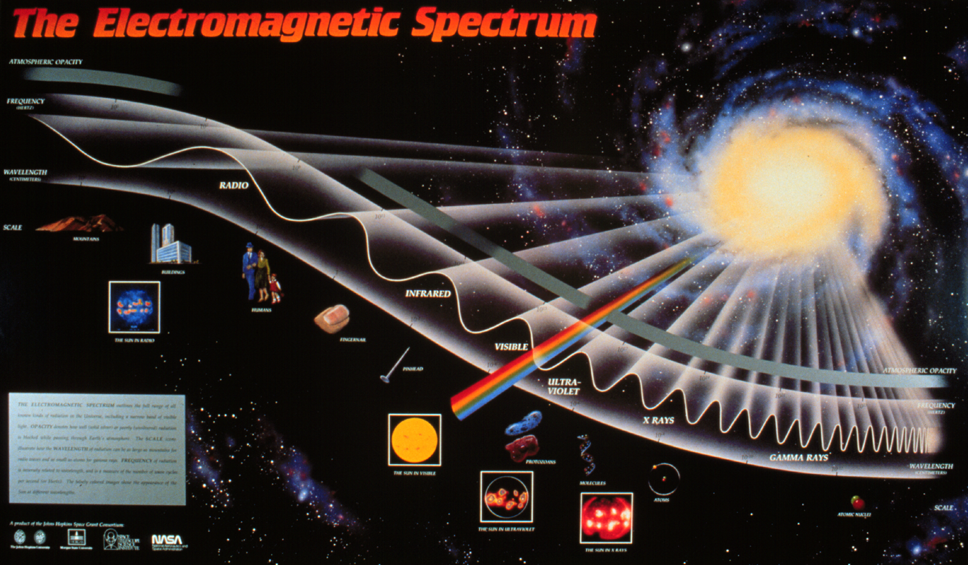

Models are necessary in helping us understand relationships, but they can also be misleading. To use models effectively, it is important to understand how a model may be different from what it represents. You are familiar with models – we use them to help us “see” things that are too large for us to see – such as the Milky Way Galaxy – and things that are too small, such as the structure of an atom. Models can also help us understand what happens when the time it takes for things to happen is very long – the orbit of a comet for example. Models can take many forms. Some are physical models, such as maps and the chart of the electromagnetic spectrum pictured above, for example. Others are mental models, such as the Bohr model of the atom that comes to mind when we think of atoms. Still other models are mathematical, such as the equations that model the curvature of spacetime, which is impossible to make into a physical model, or even into a mental image.

All of these models have distortions. Flat maps of the Earth get more exaggerated towards the edges – putting a round shape onto a flat surface causes some of the countries to look larger than they really are. The larger the concept the model is describing, the larger the amount of distortion in the model. However, models are still useful because they help us see relationships, and because they are convenient. A flat map may be folded up and put in your pocket. So there are trade-offs between accuracy and convenience whenever you construct a model.

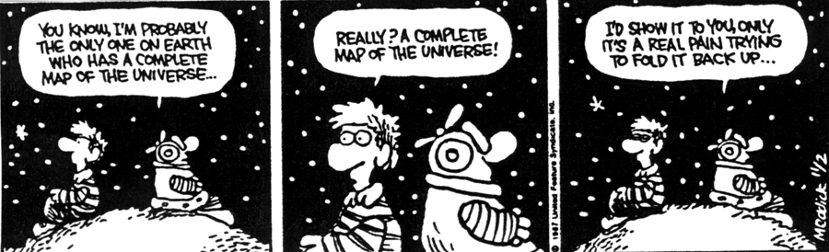

Logarithmic Versus Linear Scale Models of the Electromagnetic Spectrum

The model of the electromagnetic spectrum pictured at the top of the previous page is used extensively in textbooks and on posters, and like all other models is contains distortions. The model is extremely useful for showing the frequencies of the different bands of electromagnetic radiation (EMR), and the relationships between frequency and wavelength. However, this is a logarithmic scale, and severely distorts the actual width of the different bands of radiation. The result is that looking at this model gives you the wrong idea that the radio band is very large compared to the X-ray band, for example. You are going to construct both models, logarithmic and linear, on the same chart and compare the two scales.

- Tape four pieces of 8½” by 11½” paper together end-to-end so that their long sides are on the bottom. The pieces of paper should overlap by 3 cm. Then draw a line down the left side of the chart about 2½ cm from the edge. (See diagram below which shows orientation of first two pieces of paper.)

From the line you have just drawn, draw two horizontal lines extending to the
right across the page: one line 8 cm from the top of the chart, and the other line
line 10 cm below the first horizontal line. (See diagram below.)

- The top line will be used to plot the logarithmic scale. Along this line, mark off
24 1-cm intervals from the vertical line you drew. Starting at 1 cm, label each interval with increasing powers of ten, from 10¹ to 10²⁴. These numbers represent the frequency in Hertz of the electromagnetic spectrum. Use the information from the Frequency Range Table on the following page to divide your scale into the individual bands of electromagnetic radiation. (Use only the entire visible band, not the individual colors.)

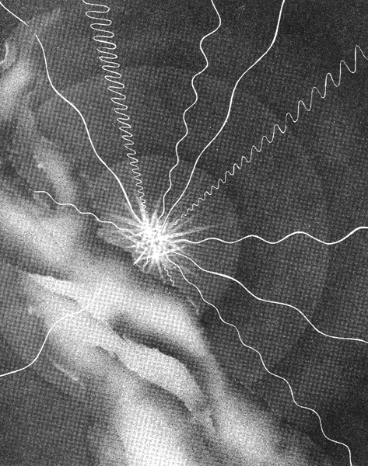
Degrees of Radiation
Lola Chaisson, Artist

Frequency Range Table

EMR Bands ~Frequency Range (Hertz) 10¹⁴ Conversions

Radio and Microwave…….Near 0 to 3.0 x 10¹²
Infrared…………………….3.0 x 10¹² to 4.6 x 10¹⁴
Visible………………………4.6 x 10¹⁴ to 7.5 x 10¹⁴

Red………………………...4.6 x 10¹⁴ to 5.1 x 10¹⁴
Orange…………………….5.1 x 10¹⁴ to 5.6 x 10¹⁴
Yellow……………………..5.6 x 10¹⁴ to 6.1 x 10¹⁴
Green……………………...6.1 x 10¹⁴ to 6.5 x 10¹⁴
Blue………………………..6.5 x 10¹⁴ to 7.0 x 10¹⁴
Violet……………………....7.0 x 10¹⁴ to 7.5 x 10¹⁴
Ultraviolet………………….7.5 x 10¹⁴ to 6.0 x 10¹⁶
X-ray………………………..6.0 x 10¹⁶ to 1.0 x 10²⁰
Gamma Ray………………..1.0 x 10²⁰ to ……..

- Before you can construct the linear scale, it is necessary to convert the frequencies that you used for the logarithmic scale. Those numbers simply told you the range of frequencies, or amount of energy, that each of the bands of EMR covers within the spectrum. Now we want to compare the actual width of each of the bands of radiation. We can do this by converting all of the bands of EMR to the same frequency range, and then plotting the width of the bands relative to each other within that same frequency range. We will arbitrarily select the frequency range that the visible band falls into – 10¹⁴. Convert the frequency numbers for all bands except visible in the Frequency Range Table above to 10¹⁴ and record them on the chart.

- Mark off 10 10-cm intervals from the vertical line. Starting at the first interval, label each mark as a whole number times 10¹⁴, from 1 x 10¹⁴ to 10 x 10¹⁴. Label the bottom of your model “Frequency in Hertz.” You can now plot some of the 10¹⁴ frequencies you calculated on the bottom line of your constructed model. Plot the individual colors of the visible spectrum and color them. Compare the two scales. Do the results surprise you?

- How far does the ultraviolet band extend? Using the scale you have started and the roll of string provided, calculate and roll out the distance which represents the width of the ultraviolet band of radiation.

- X-rays are the next band of radiation. Calculate the distance from the end of the ultraviolet band to the end of the X-ray band. Obtain a map from the Internet or use a local or state highway map to plot the distance.



